SELECT * FROM pizza_sales;

SELECT COUNT(DISTINCT(order_id)) FROM pizza_sales;

--Total Revenue

SELECT SUM(total_price)AS Total_revenue FROM pizza_sales;

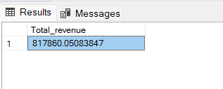

--Average Order value

SELECT SUM(total_price)/COUNT(DISTINCT(order_id)) AS Avy_order_value FROM pizza_sales;

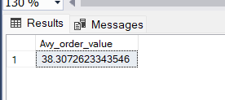

--Total pizza sold

SELECT SUM(quantity)AS Total_pizza_sold FROM [pizza_sales ]

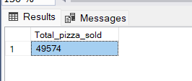

--Total orders

SELECT COUNT(DISTINCT(order_id))AS Total_order FROM pizza_sales;

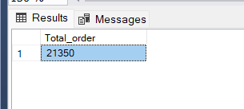

--Average Pizzas per order

SELECT CAST(CAST(SUM(quantity) AS DECIMAL(10,2))/

CAST(COUNT(DISTINCT (order_id))AS DECIMAL(10,2))AS DECIMAL(10,2))AS Avg_pizzas_per_order FROM pizza_sales;

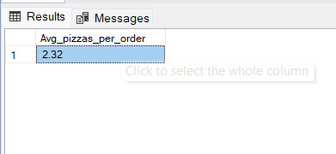

--Daily trend of total order

SELECT DATENAME(DW, order_date) AS order_day , COUNT(DISTINCT order_id) AS Total_orders

FROM pizza_sales

GROUP BY DATENAME(DW, order_date);

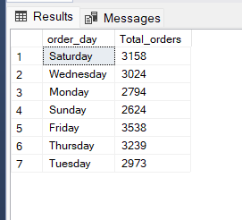

--Monthly Trend for the orders

SELECT DATENAME(month,order_date)AS Month_Name , COUNT(DISTINCT (order_id))AS Total_orders

FROM pizza_sales

GROUP BY DATENAME(month,order_date)

ORDER BY Total_orders DESC;

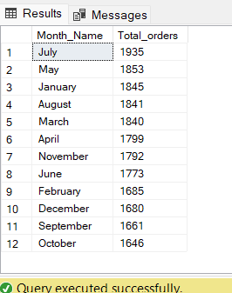

--Percentage of sales by pizza category

SELECT pizza_category ,CAST(SUM(total_price)AS DECIMAL (10,2))AS total_sales,CAST(SUM(total_price)*100/

(SELECT SUM(total_price)FROM pizza_sales) AS DECIMAL (10,2))AS PCT

FROM pizza_sales

GROUP BY pizza_category;

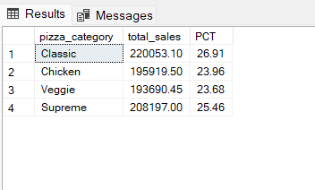

--Percentage of sales by pizza size

SELECT pizza_size ,CAST(SUM(total_price)AS DECIMAL (10,2))AS total_sales,CAST(SUM(total_price)*100/

(SELECT SUM(total_price)FROM pizza_sales) AS DECIMAL (10,2))AS PCT

FROM pizza_sales

GROUP BY pizza_size;

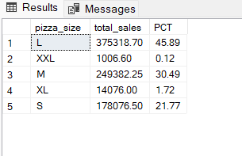

--Total Pizza sold by category

SELECT pizza_category,SUM(quantity)AS Total_Pizzas_sold FROM pizza_sales

GROUP BY pizza_category;

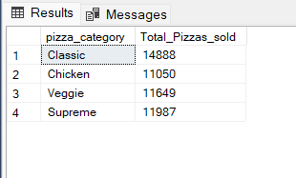

--Top 5 Pizzas by Revenue

SELECT Top 5 pizza_name, SUM(total_price) AS Total_Revenue

FROM pizza_sales

GROUP BY pizza_name

ORDER BY Total_Revenue DESC;

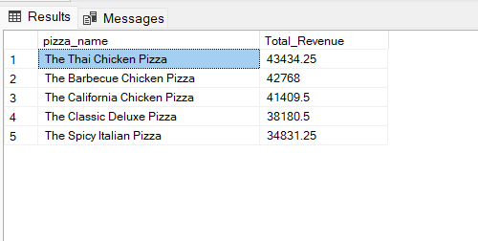

--Top 5 best sellers by Total Pizzas Quantity

SELECT TOP 5 pizza_name,SUM(quantity)AS Total_Pizzas_sold

FROM pizza_sales

GROUP BY pizza_name

ORDER BY SUM(quantity) DESC ;

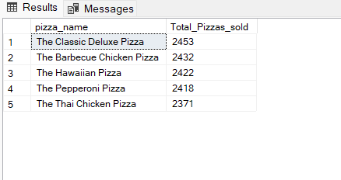

--Top 5 Pizzas by Total Orders

SELECT Top 5 pizza_name, COUNT(DISTINCT order_id) AS Total_Orders

FROM pizza_sales

GROUP BY pizza_name

ORDER BY Total_Orders DESC;

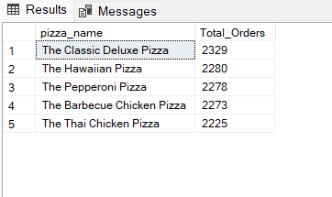

--Bottom 5 Pizzas by Revenue

SELECT Top 5 pizza_name, SUM(total_price) AS Total_Revenue

FROM pizza_sales

GROUP BY pizza_name

ORDER BY Total_Revenue ASC

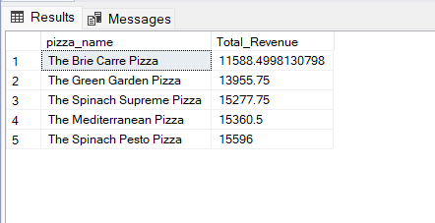

--Bottom 5 Pizzas by Quantity

SELECT TOP 5 pizza_name, SUM(quantity) AS Total_Pizza_Sold

FROM pizza_sales

GROUP BY pizza_name

ORDER BY Total_Pizza_Sold ASC;

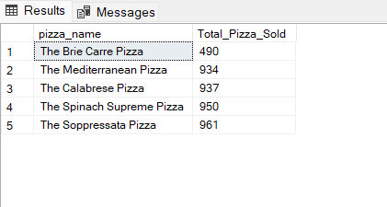

--Bottom 5 Pizzas by Total Orders

SELECT Top 5 pizza_name, COUNT(DISTINCT order_id) AS Total_Orders

FROM pizza_sales

GROUP BY pizza_name

ORDER BY Total_Orders ASC

